

CA1: Database Design and Development

Module Title: Database Design and Development

Module Code: B8IT113

Module Leader: Jennifer Byrne

Student Name: Krisztian Kozsa

Student Code: 10634329

Contents

1. Project Overview/Scope 3

2. Entity Relationship Diagram 4

3. Assumptions Made 5

4. Data Dictionary 5

5. Technology Used 5

6. Test Plan 5

7. Reflections on Learning 6

8. References 6

9. SQL 6

# Project Overview/Scope

This project provides a technical design and provision of a new database server and the development of a new database for a car sales and servicing company. It handles inventory of new cars, used cars, car service, customer and employee information. The company will be able to create, edit or delete database records on daily basis. The car sale and service history will be recorded against the car’s registration number. Customer information might be deleted according to GDPR compliance, while business critical data will be kept.

# 

# Entity Relationship Diagram

Place a copy of your Entity Relationship Diagram (ERD) here.

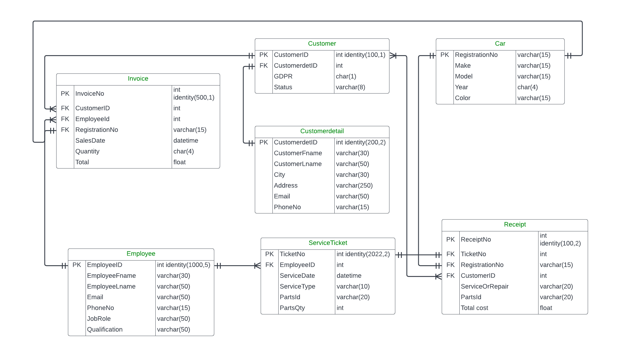

# 

# Assumptions Made

The MI extract will run manually or automatically each day.

I assume there is a secure payment system that out of scope of this design.

I assume there is a HR system linked to this database.

# Data Dictionary

All Data Dictionary based on ERD above.

Car

|  |  |  |  |
| --- | --- | --- | --- |
| **Attribute** | **Datatype** | **Required** | **Description** |
| RegistrationNo (PK) | varchar(15) | Y | Car registration number e.g. 141-C-34567 |
| Make | varchar(15) | Y | Make of the car e.g. Audi |
| Model | varchar(15) | Y | Car model e.g. A6 |
| Year | char(4) | Y | Year of manufacturing of car e.g. 2014 |
| Color | varchar(15) | Y | Color of car e.g. Smurf blue |

Customer

|  |  |  |  |
| --- | --- | --- | --- |
| **Attribute** | **Datatype** | **Required** | **Description** |
| CustomerID (PK) | Int identity(100,1) | Y | Customer unique ID e.g. 100 |
| CustomerdetID (FK) | Int | Y | Customer detail unique ID e.g. 200 |
| GDPR | char(1) | Y | GDPR status request: y / n |
| Status | varchar(8) | Y | Customer status: active / inactive |

Customerdetail

|  |  |  |  |
| --- | --- | --- | --- |
| **Attribute** | **Datatype** | **Required** | **Description** |
| CustomerdetID (PK) | Int identity(200,2) | Y | Customer detail unique ID e.g. 200 |
| CustomerFname | varchar(30) | Y | Customer first name e.g. Joe |
| CustomerLname | varchar(50) | Y | Customer last name e.g. Higgins |
| City | varchar(30) | Y | Customer city e.g. Dublin |
| Address | varchar(250) | Y | Customer address e.g. 34 Arran Quay |
| Email | varchar(50) | Y | Customer email e.g. joeh@mail.com |
| PhoneNo | varchar(15) | Y | Customer phone no. e.g. 0865461235 |

EMPLOYEE

|  |  |  |  |
| --- | --- | --- | --- |
| **Attribute** | **Datatype** | **Required** | **Description** |
| EmployeeID (PK) | Int identity(1000,5) | Y | Employee unique ID e.g. 1000 |
| EmployeeFname | varchar(30) | Y | Employee first name e.g. Patrick |
| EmployeeLname | varchar(50) | Y | Employee last name e.g. Costello |
| Email | varchar(50) | Y | Employee email e.g. pcostello@mail.com |
| PhoneNo | varchar(15) | Y | Employee phone no. e.g. 0854956815 |
| Jobrole | varchar(50) | Y | Employee job role e.g. Mechanic |
| Qualification | varchar(50) | Y | Employee qualification e.g. Engineer |

SERVICE TICKET

|  |  |  |  |
| --- | --- | --- | --- |
| **Attribute** | **Datatype** | **Required** | **Description** |
| TicketNo (PK) | Int identity(2022,2) | Y | Service ticket unique No. e.g. 2022 |
| EmployeeID (FK) | int | Y | Employee unique ID e.g. 1000 |
| ServiceDate | datetime | Y | Date of service e.g. 06-06-2022 |
| ServiceType | varchar(10) | Y | Type of service e.g. service / repair |
| PartsID | varchar(20) | Y | Parts used for service e.g. Filter05, Bearing09 |
| PartsQty | int | Y | Quantity of parts used e.g. 5 |

RECEIPT

|  |  |  |  |
| --- | --- | --- | --- |
| **Attribute** | **Datatype** | **Required** | **Description** |
| ReceiptNo (PK) | Int identity(100,2) | Y | Receipt unique No. e.g. 100 |
| TicketNo (FK) | Int | Y | Service ticket unique No. e.g. 2022 |
| RegistrationNo (FK) | varchar(15) | Y | Car registration number e.g. 141-C-34567 |
| CustomerId (FK) | Int | Y | Customer unique ID e.g. 100 |
| ServiceOrRepair | varchar(20) | Y | Type of service e.g. service / repair |
| PartsID | varchar(20) | Y | Parts used for service e.g. Filter05, Bearing09 |
| TotalCost | float | Y | Total cost of service e.g. 1380 |

INVOICE

|  |  |  |  |
| --- | --- | --- | --- |
| **Attribute** | **Datatype** | **Required** | **Description** |
| InvoiceNo (PK) | Int identity(500,1) | Y | Invoice unique No. e.g. 500 |
| CustomerID (FK) | Int | Y | Customer unique ID e.g. 100 |
| EmployeeID (FK) | Int | Y | Employee unique ID e.g. 1000 |
| RegistrationNo (FK) | varchar(15) | Y | Car registration number e.g. 141-C-34567 |
| SalesDate | datetime | Y | Date of purchase e.g. 06-06-2022 |
| Quantity | Char(4) | Y | Quantity of invoices e.g. 1 |
| Total | float | Y | Invoice total e.g. 53850 |

# Technology Used

List all technologies used.

Lucid chart

Microsoft SQL server management studio

SQL server

Microsoft Word

Brave browser

# Test Plan (all about store procedure)

Table 1 – the test plan

|  |  |  |  |
| --- | --- | --- | --- |
| Item Tested | Test Run | Expected Result | Actual Result |
| InsertCustomerdetail | exec InsertCustomerdetail 'George','Curran','Dublin','45 Cork street','gcurran@mail.com','0855556412' | Insert new customer details | Customer details inserted |
| InsertCustomer | exec InsertCustomer '212','y','Active' | Insert new customer | Customer inserted |
| InsertCar | exec InsertCar '05-C-5956','Suzuki','Swift','2005','Emerald Green' | Insert new car | Car inserted |
| InsertEmployee | exec InsertEmployee 'Mark','Ryan','mryan@mail.com','0866544561','Mechanic','Engineer' | Insert new employee | Employee inserted |
| InsertServiceticket | exec InsertServiceTicket'1030','11/06/2022','Service','Tire02','4' | Insert new service ticket | Service ticket inserted |

# Reflections on Learning

Without any previous experience in SQL , it was difficult to understand the relation between attributes and entities. Primary keys and foreign keys were also confusing in the first few classes. Practice and the visualisation of Lucidchart made everything clear. As Lucidchart export the SQL code with errors (missing foreign keys), I had to spend some time with research to find out how foreign keys inserted manually in SQL. Overall I gained a lot of knowledge in SQL and I am much more confident than before the course.

# References

List all reference material used:

B8IT113 Database Design and Development notes and videos

<https://www.w3schools.com/sql/>

<https://www.reddit.com/r/SQL/>

# DDL & DML Running Order

A list of all SQL files to be run and in what order should be placed here. This should include the SQL to:

1. Create Tables: Car details 10.sql, line 1-91
2. Insert Data: Car details 10.sql, line 93-162
3. Create Procs: Car details 10.sql, line 165-349
4. Create Views: Car details 10.sql, line 352-380